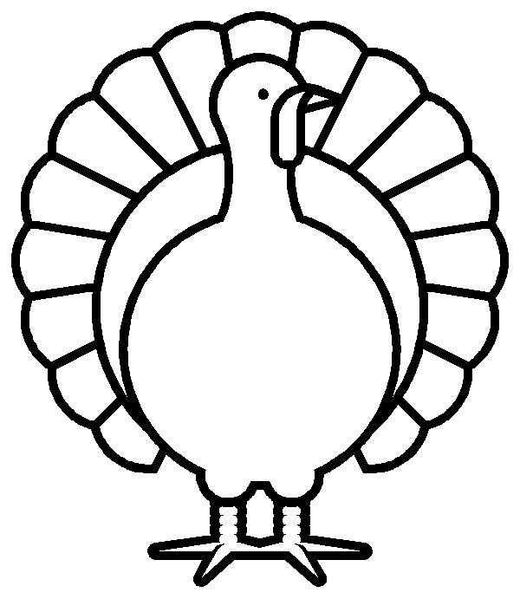

1. Which teams play in a state that borders its home state?

2. Which team travels the greatest distance this week? Which team travels the least distance this week?

3. Which games are being played in where the team is named after their state?

4. Which Game is being played in the Big D? Which game is being played in Motown?

5. Which teams travel over the Mississippi river to play their games this week?

6. Which city will host a game this week that is also the city where President Kennedy was shot?

7. Color the feathers according to which team you think will win based on the board.